**IS 340 - Operating Systems**

**HOP02A –GitHub**

04/19/2020 Developed by Kim Nguyen

10/03/2020 Reviewed by Kim Nguyen

School of Technology & Computing @City University of Seattle (CityU)

Image result for github

**Before You Start**

* **If you already have a GitHub account, you can skip this section**
* Version numbers may not match with the most current version at the time of writing. If given the option to choose between stable release (long-term support) or most recent, please choose the stable release rather than beta-testing version.
* This tutorial targets Windows users and MacOS users.
* There might be subtle discrepancies along the steps. Please use your best judgement while going through this cookbook style tutorial to complete each step.
* For your working directory, use your course number. This tutorial may use a different course number as an example.
* The directory path shown in screenshots may be different from yours.
* If you are not sure what to do or confused with any steps:
  1. Consult the resources listed below.
  2. If you cannot solve the problem after a few tries, ask a TA for help.

**Learning Outcomes**

Students will be able to:

* Create GitHub account

**Before you start**

Version control system (VCS) is created to makes it easy to store different versions of the project you are working at any time (without any fixed rules, time or rules). You can easily restore an earlier record and compare the content with the current data to find the differences. In addition, it also an effective tool to cooperate with many other people in the same project. In this module, we will learn about one of the most popular VCS which is Git and GitHub.

**Create an account on GitHub**

1. Visit <https://github.com/> and click on “Sign up for GitHub”

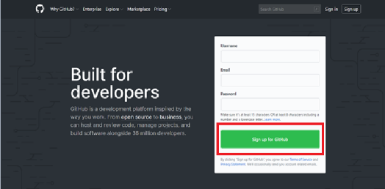

1. Filling in the form with Username, Email Address, Password and etc. It is very straightforward.

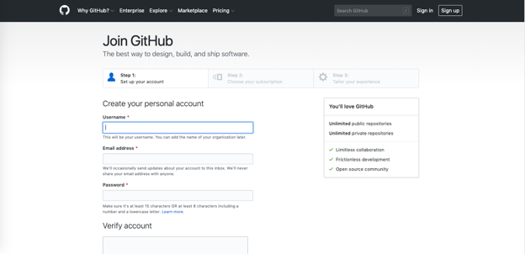

1. Click “Create Account” to proceed to next page
2. On Step 2, Choose your subscription as “Free” and click “Continue”

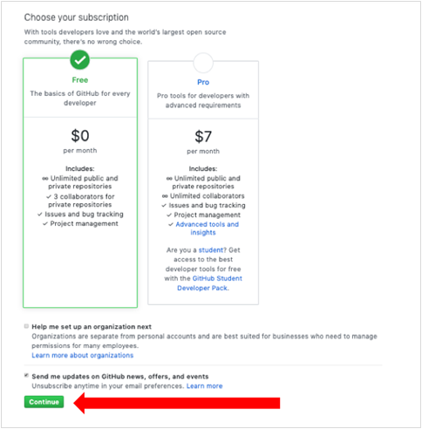

1. On Step 3, just be honest and choose your options then click “Submit” or you can just click on ‘skip this step’

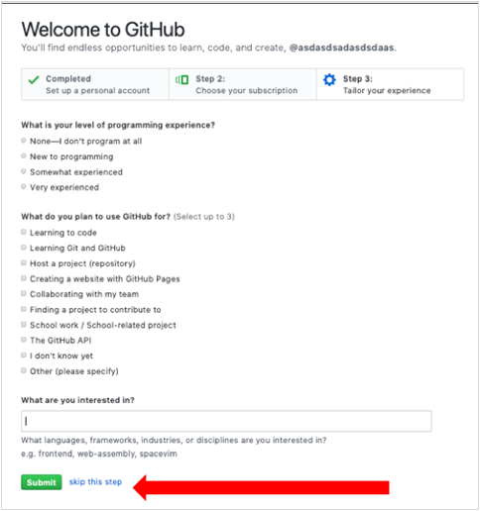

1. After that, you will be asked to check your email and verify your GitHub account
2. Go to github.com and login to your GitHub account.